**“Innovation and Entrepreneurship”**

**Artificial Intelligence and Its Impact on Cancer Treatment**

| Name | AEM |
| --- | --- |
| Δημήτριος Αίαντας Καλής | 3790 |
| Στυλιανός Τσερνικούδης | 4042 |
| Μαριάννα Φουδούλη | 4006 |

**Ακαδημαϊκό έτος 2023-2024**

**Content**

1. General information (page 3)
2. AI in cancer treatment (page 4)
3. Test and success rate (page 5)
4. AI use in skin cancer detection (page 6)
5. AI use in breast cancer detection (page 7-8)
6. Prostate cancer (page 9)
7. Gastric cancer (page 10-11)
8. Challenges and potential dangers (page 12)
9. References (page 13-14)

**Utilizing Artificial Intelligence in Oncology: A Comprehensive Overview of Cancer and its Medical Application**

[1] Cancer is a life-threatening disease characterized by abnormal cellular growth and division. Cancerous cells develop uncontrollably, forming a mass known as a malignant 'tumor' or 'neoplasm'. Treatments for cancer do exist, however, their effectiveness depends on the specific type of cancer and the stage at which it is diagnosed.

[2] At its simplest form, artificial intelligence is a field, which combines computer science and robust datasets, to enable problem-solving. It also encompasses sub-fields of machine learning and deep learning, which are frequently mentioned in conjunction with artificial intelligence. These disciplines are comprised of AI algorithms which seek to create expert systems which make predictions or classifications based on input data.

[3] Within healthcare, artificial intelligence (AI) encompasses the utilization of software, specifically machine-learning algorithms, to replicate human-like cognitive abilities in comprehending complex medical data. Its primary aim is to derive insights solely from input data. The fundamental objective of AI in healthcare revolves around examining correlations between patient outcomes and clinical procedures. What sets AI apart from conventional methods is its capacity to collect, process, interpret data, and yield conclusive outputs.

AI employs deep learning techniques and machine learning methodologies to achieve these goals. These systems possess the capability to recognize behavioral patterns and generate independent reasoning. Presently, AI-based information finds application in various medical domains, including diagnostic procedures, drug development, personalized medicine, patient monitoring, and the formulation of treatment protocols.

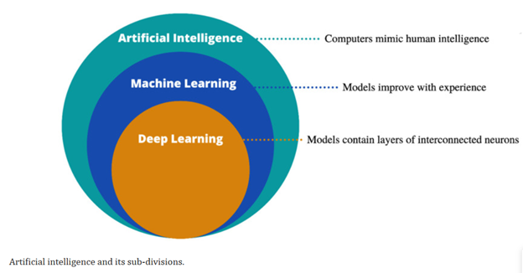

**Use of Artificial Intelligence in cancer treatment**

[3] Artificial Intelligence (AI) can undergo training to recognize distinct patterns indicative of cancer development, facilitating predictive analysis even before the formation of cancerous cells. This trained AI capability enables early prediction and detection of potential cancerous conditions based on identified patterns, contributing to proactive intervention and preventive measures. The medical field has dedicated substantial resources to the advancement and development of applications harnessing Artificial Intelligence (AI) for predictive analysis in recent years. This commitment reflects the recognition of the potential of AI-based tools in early detection and proactive intervention in various health conditions, particularly in the context of cancer and its timely identification.

Artificial Intelligence profoundly impacts medical imaging in fields like radiology and pathology, revolutionizing cancer care. AI, especially Deep Learning (DL), assists in various stages—from improving cancer screening by classifying images to identifying often-missed lesions like lung nodules or brain metastases. It precisely segments and characterizes lesions, aiding treatment planning and prognosis. Radiomics, using AI-extracted features, predicts treatment responses, while AI models differentiate cancer types from images. AI transforms cancer monitoring, identifying subtle changes imperceptible to humans. Additionally, AI models like Generative Adversarial Networks (GANs) create synthetic imaging for better treatment planning. In pathology, AI achieves high accuracy in classifying histology and dermatoscopic images. As AI applications enter clinical practice, ongoing refinement and education are crucial for effective integration into real-world scenarios, necessitating a skilled workforce in AI and oncology.

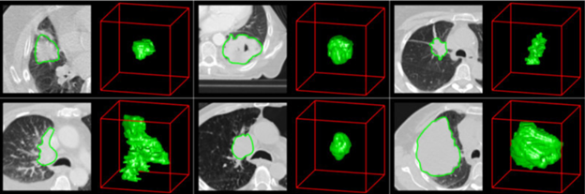

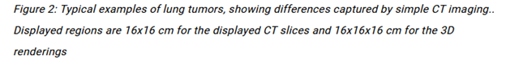

**Tests and success rates**

[3] Recent studies have indicated that a substantial proportion, specifically 70%, of human cancer diagnoses performed by healthcare professionals are susceptible to reclassification with the use of ai. This potential reclassification holds the promise of altering the selection and application of treatments aimed at combating these cancers. Such reclassification could significantly enhance the success rates of these treatments, thereby offering greater efficacy in managing and potentially curing various forms of cancer.

In 2021, a notable study demonstrated the remarkable capability of artificial intelligence (AI) in predicting the presence of mesothelioma with an impressive success rate of 96%. Furthermore, this AI technology exhibited a diagnostic accuracy of 97% in discerning between two prevalent types of lung cancer: adenocarcinomas and squamous cell carcinomas. These particular cancer types pose a considerable challenge in differentiation even for seasoned pathologists. The study's findings underscore the potential of AI as a highly accurate tool in not only detecting mesothelioma but also in effectively distinguishing between challenging lung cancer subtypes, potentially aiding in more precise and timely diagnosis for improved patient outcomes.

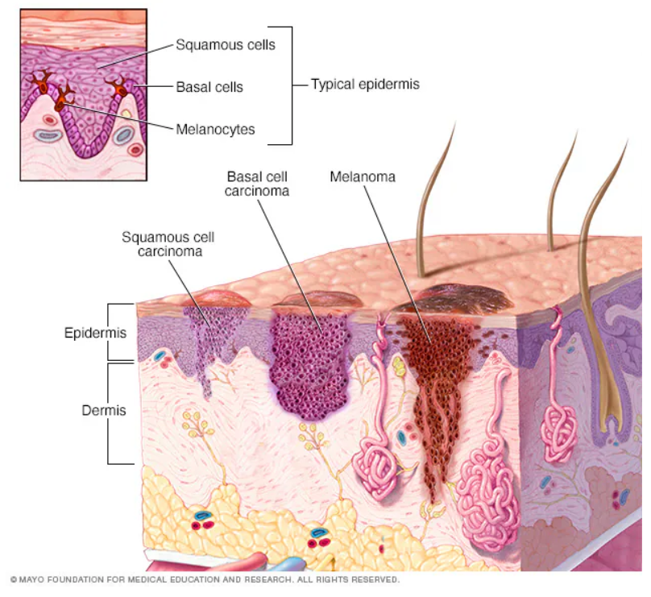

**AI use in skin cancer detection:**

[6] Skin cancer is the most common type of cancer, with non-melanoma skin cancers being more prevalent. [7] When detected early it is highly treatable, however, its diagnosis requires the involvement of skin cancer specialists, making it a costly procedure and not easily available in developing countries. The apparent scarcity of skin cancer specialists has created the need to automate the diagnostic procedure. As a result, several AI-based methods have been proposed that aim to assist in the early diagnosis of skin cancer and subsequently reduce its morbidity and mortality.

[8] Artificial Neural Networks (ANNs) can be used to predict the likelihood of non-melanoma cancer emergence. The models are being trained using validated parameters, such as gender, age, vigorous exercise habits, hypertension, heart disease, asthma etc, as input data, which are then normalized to values between 0 and 1 to improve the accuracy. ANNs may also use images as training data, namely dermoscopic images. The algorithm can then analyze features such as asymmetry, border irregularities, color variation and size, to learn how to identify and classify different skin lesions.

[9] In a clinical setting, general practitioners are often the first doctors that patients contact about a concerning lesion. Such AI-based tools can be used as an aid in their decision making, for example whether a particular lesion warrants a biopsy or not, which in turn can improve the patient experience and minimize the costs. Furthermore, a more accurate initial diagnosis by a general practitioner, may contribute to the earlier diagnosis of cancer, thus improving patient outcomes.

[10] Smartphone applications have also been developed, with several “mole checker” type of applications available on the app store, to be used both by patients and clinicians alike. These applications take as an input a mobile photo of a lesion and attempt to identify patterns that may be indicative of skin cancer. This can be particularly useful for telemedicine and remote diagnosis.

A common problem that all these AI models face is the quality of the images that are used as input data. In perfect circumstances they may reliably predict skin cancer, however, in practice there are discrepancies in the lighting of images, skin irregularities or body hair may be present and skin cancers may present differently on different skin colors. Therefore, there is a high potential that benign moles may be mis-identified as cancerous, leading patients to be subjected to unnecessary tests.

***Similarity of normal lesion (left) and melanoma (right):***

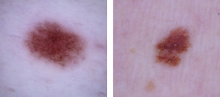

**AI use in breast cancer detection:**

[11] Breast cancer is the second most common cancer that affects women. While it can also affect men, its incidence is less than 1% of all confirmed cases of breast cancer. It is estimated that in the USA 1 in 8 women will have to deal with this type of cancer at some point in her life, with the risk increasing as she ages.

The high incidence of this cancer has bred awareness, with many women getting tested regularly and new drugs and treatments being invented. As a result, survivability is generally high and, in fact, on an upward trend. Still though, the biggest predictor of a favorable outcome is the timely diagnosis of the cancer.

[12] Computer assisted diagnosis (CAD) is widespread among radiologists and is being used in conjunction with mammography to detect cancerous cells. When making a diagnosis, CAD uses pattern recognition software that distinguishes unfamiliar forms in the image for the physician to consider. Thereby CAD enhances the interpretation competence and analytical routine of radiologists by saving reading time and preserving the steadiness of the lesion recognition. It serves as a second pair of eyes substituting the need for a second reading by another radiologists.

[14] CAD may also help detect breast cancer earlier. It is estimated that about 50% of breast cancers detected mammographically can be retroactively seen in prior studies. Some of these cancers may be obscured by the surrounding anatomy, or simply be missed by human error. [13] AI models have shown excellent results in the reduction of screening errors, contributing to the timely diagnosis of often missed cancers.

[17] Another area that AI has contributed to is the creation of breast cancer risk models. These models rely on mammography images to detect high risk patients and studies have shown that there’s good correlation between the patients that the models identified as high risk and the patients that eventually went on to develop breast cancer within the next 5 years. These models can determine how often someone should get screened for breast cancer, raising awareness and potentially improving outcomes.

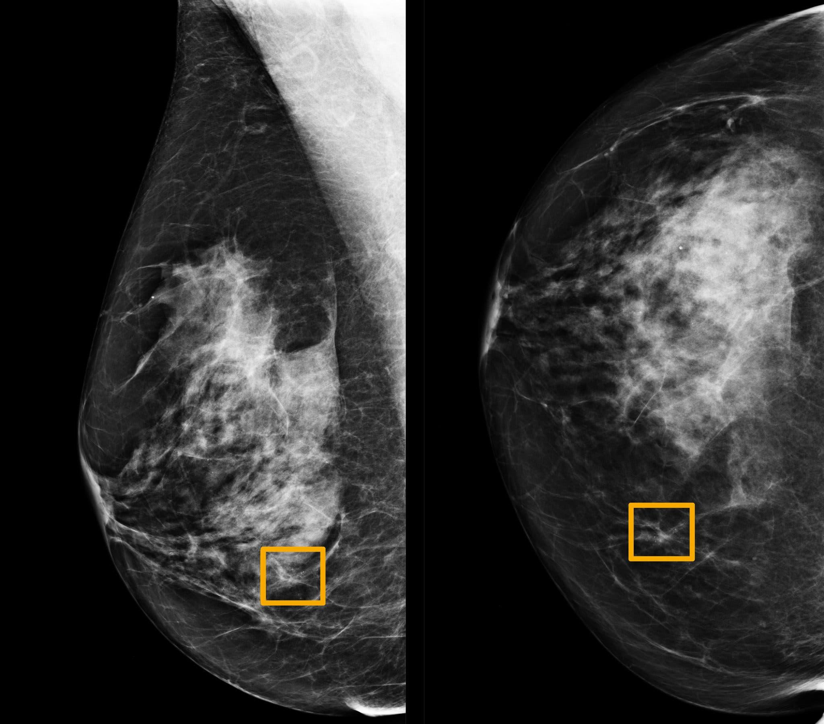

[16] ***A yellow box indicates where an A.I. system found cancer hiding inside breast tissue. Six previous radiologists failed to find the cancer in routine mammograms.***

***Credit...***

***Northwestern University***

**Prostate cancer:**

[4]Before the advent of AI in the medical field, the diagnosis of prostate cancer primarily relied on conventional methods, including a digital rectal exam(DRE), a prostate-specific antigen test(PSA), biopsy and the assignment of a Gleason score by a pathologist. While this approach contributed significantly to a reduction in prostate cancer related deaths it also resulted in overdiagnosis and overtreatment of non-aggressive prostate cancers. Moreover the subjective nature of human interpretation introduced potential errors in diagnosis. The addition of AI into prostate cancer diagnosis has revolutionized the approach by using advanced algorithms to analyze medical images with much higher precision than the human eye. This is crucial in the interpretation of magnetic resonance imaging(MRI), ultrasound and histopathology images , which play a big role in assessing the nature and aggressiveness of prostate tumors. AI models excel in image analysis by performing tasks such as segmentation, allowing for accurate identification and delineation of the prostate and associated abnormalities. AI algorithms can detect subtle patterns, textures and features within these images that might escape human detection. This detailed analysis contributes to a more nuanced understanding of the tumor and its characteristics.

A major advantage in the application of AI in the diagnosis is the ability to minimize errors and human subjectivity. The automation of the analysis reduces the need for individual interpretation, leading to more consistent and objective results. The use of AI has the potential to streamline the diagnostic process. By providing a more precise characterization of the cancer’s aggressiveness it enables professionals to make informed decisions about treatment strategies. This, in turn, facilitates a more efficient and targeted approach, allowing for the identification of high-risk cases that require immediate intervention while sparing patients from unnecessary treatments.

The integration of AI in cancer diagnosis represents a shift towards more personalized and efficient healthcare.By harnessing the power of artificial intelligence the medical community can not only improve diagnostic accuracy but also mitigate the challenges associated with overdiagnosis and overtreatment, ultimately leading to more effective and patient-centered care .

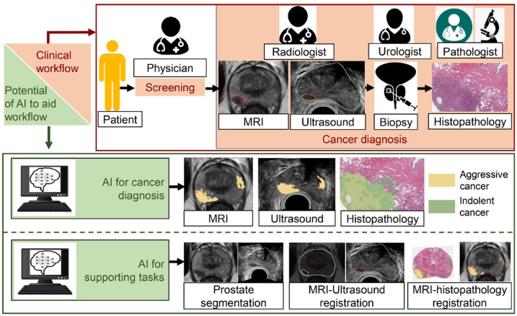

**Gastric cancer:**

[5]The landscape of diagnosing and treating gastric cancer (GC) is undergoing a revolutionary change, thanks to the infusion of Artificial Intelligence (AI). Picture this – from the eyes of endoscopes to unraveling the molecular secrets and deciding on treatment plans, AI is emerging as a game-changer, making interventions more efficient and precise. One remarkable feat of AI is its ability to predict the depth of tumor invasion, a crucial aspect in GC diagnosis. Using sophisticated algorithms, AI models shine in classifying tumor stages, especially in the early phases of Gastric Cancer (EGC). This not only aids in accurate diagnosis but also provides crucial insights for tailoring effective treatment plans. When it comes to peering into the inner workings of gastric cancer, AI takes the lead in Computed Tomography (CT) scans. It goes beyond merely capturing images, excelling in predicting tumor depth, gauging lymph-node metastasis, and even foreseeing peritoneal metastasis. The result? Better staging accuracy for Advanced Gastric Cancer (AGC) and smarter decisions in treatment and prognosis. AI doesn't stop at images; it delves into the molecular intricacies of GC. Whether it's understanding the role of Her2, gauging Microsatellite Instability (MSI), or deciphering Chromosomal Instability (CIN), AI plays a pivotal role. Using CT images, it offers a less invasive path to identify molecular subtypes, paving the way for personalized treatment decisions. In the world of treatment decisions, AI acts as a trusted guide. From steering endoscopic resection for EGC to lending a hand in choosing chemotherapy and targeted therapies for AGC, AI's prowess is evident. It goes a step further, predicting how patients will respond to treatment and providing insights that empower clinicians to tailor therapies based on individual patient profiles. Picture this – AI contributing to the precision of tumor resection. Whether it's the detailed view of chromoendoscopy or the broader perspective of white-light endoscopy, AI plays a crucial role in ensuring tumors are removed completely during endoscopic procedures.Yet, with all these strides, challenges persist. AI grapples with data scarcity and the need for better interpretability. The road ahead involves solutions like federated learning, enhancing interpretability, and building algorithms that understand multiple aspects simultaneously. As AI seamlessly integrates into the realm of GC diagnosis and treatment, it's not just about technology; it's about transforming patient care. This collaboration between AI and human expertise marks a new chapter in oncology, promising more informed decisions, better patient outcomes, and a future where technology and compassion walk hand in hand.

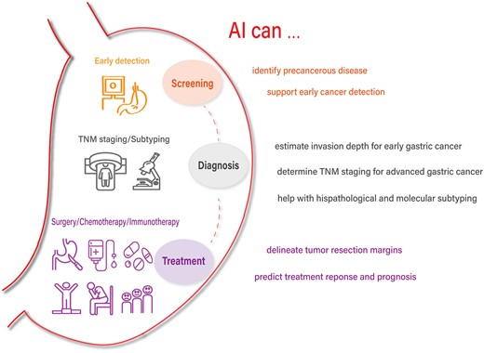

**Challenges and potential dangers:**

[15] [3] One can easily reach the conclusion that AI in the field of cancer detection is an exciting new technology that has the potential to become a mainstay. However, as exciting as it is, it is not without its problems. It is no surprise that, while hundreds of algorithms have shown excellent results in early trials, very few of them are externally and independently validated and ready for the real world.

A question that needs to be answered is how can we ensure that these models will continue to work in the future. As new treatments and imaging techniques are emerging, models that have already been trained may be rendered obsolete. For example, a new scanner could change key features of the images that an AI tool relies upon to make predictions or interpretations.

Furthermore, those models require robust amounts of data that ,due to their sensitive nature, may be hard to acquire. Questions of security may also arise. Where can this data be stored, how can we prevent leaks and how can we preserve patients’ anonymity? It is of utmost importance that the data are managed according to guiding principles, to address security concerts and maximize their utility.

We also need to ensure that the AI is “de-gentrified”. We need to prevent the accumulation of the technology in big medical centers with specialized personnel, while smaller, remote ones are being ignored. One could argue that non specialized centers may actually benefit more from the implementation of AI, since as it stands the technology is unlikely to spot something a highly experienced radiologist will miss, but might help in cases where such specialization doesn’t exist. Efforts must be made to eliminate the technological gap and ensure equal treatment of patients, regardless of hospital.

Lastly, and perhaps most importantly, measures must be taken to reduce and if possible eliminate algorithmic bias. This apparent bias is likely to stem from the datasets the models are using to learn. It has become clear that people belonging to minorities and in general socially vulnerable groups are underrepresented in the data (perhaps from a lack of access to healthcare due to financial or societal reasons) and as a result the AI performs worse on those patients. Thus it may help perpetuate an already existing state of medical segregation .

It is debatable whether AI can overcome these challenges any time soon. However research is expected to continue and in fact increase, as the results are way too promising!

**References**

**Digital references:**

[1] National cancer institute<https://www.cancer.gov/about-cancer/treatment/types>

[2] IBM What is Artificial Intelligence<https://www.ibm.com/topics/artificial-intelligence>

[3] National library of medicine [The Role of Artificial Intelligence in Early Cancer Diagnosis](https://www.ncbi.nlm.nih.gov/pmc/articles/PMC8946688/)

[4]National library of medicine <https://www.ncbi.nlm.nih.gov/pmc/articles/PMC9554123/>

[5]Oxford Academic <https://academic.oup.com/gastro/article/doi/10.1093/gastro/goac064/6851717#383629926>

[6] National cancer institute <https://www.cancer.gov/types/skin>

[7] National library of medicine <https://www.ncbi.nlm.nih.gov/pmc/articles/PMC9953963/#:~:text=Polarized%20and%20nonpolarized%20dermoscopy%20are,132%2C133%2C134%5D.>

[8] National library of medicine <https://www.ncbi.nlm.nih.gov/pmc/articles/PMC9953963/#:~:text=Polarized%20and%20nonpolarized%20dermoscopy%20are,132%2C133%2C134%5D.>

[9] The Lancet <https://www.thelancet.com/journals/landig/article/PIIS2589-7500(22)00023-1/fulltext>

[10] Science direct <https://www.sciencedirect.com/science/article/abs/pii/S019096222202552X>

[11] American cancer society <https://www.cancer.org/cancer/types/breast-cancer/about/how-common-is-breast-cancer.html#:~:text=Overall%2C%20the%20average%20risk%20of,will%20never%20have%20the%20disease>

[12] National library of medicine <https://www.ncbi.nlm.nih.gov/pmc/articles/PMC9743193/#:~:text=To%20diagnose%20breast%20cancer%2C%20computer,%2C%20ultrasound%2C%20and%20histological%20imaging.>

[13] Imperial College London <https://www.imperial.ac.uk/news/194506/artificial-intelligence-could-help-spot-breast/>

[14] Springer <https://link.springer.com/article/10.1007/s10278-019-00192-5>

[15] National cancer institute <https://www.cancer.gov/news-events/cancer-currents-blog/2022/artificial-intelligence-cancer-imaging>

[16] New York Times <https://www.nytimes.com/2020/01/01/health/breast-cancer-mammogram-artificial-intelligence.html>

[17] National Library of medicine <https://pubmed.ncbi.nlm.nih.gov/33504648/>